Lab 10. Embedded System Design (Spring 2021)

Preparation

Restrictions on components

Spring 2021 Game proposal link:

Restrictions on software

Timetable

Teams

Purpose

Base System Requirements for all projects

System Requirements for Space Invaders, Asteroids, Missile Command, Centipede, Snood, or Defender

System Requirements for Connect Four

All students must create a proposal for their project

Procedure

Part a - Design Modules

Part b - Make the game globally aware

Part c - Generate Sprites (in progress…)

Part d - Extend Random Number Generator

Part e - Test Subsystems

Part f - Optional Feedback: http://goo.gl/forms/rBsP9NTxSy

Competition Structure

Step 1 - Checkout and Grade (5.4% of EE319K total grade)

Step 2 - YouTube Competition (0.6% for YouTube posting)

Extra fun

# Preparation

Use the starter project on Git, paste in your LCD solution code from a previous lab (collect images to display on the SSD1306 LCD)

Example game art can be found at <https://opengameart.org/>

# Restrictions on components

For this lab you may use any additional components in addition to the components given to you. For example, you can use enclosures, bigger buttons, buzzers, joysticks, speakers, amplifiers etc. The only restriction is that you must write all the low-level driver software yourself.

# Spring 2021 Game proposal link:

<https://docs.google.com/document/d/1B1_PBIVwFjSoUoKt9laAcv8IgeX3e4sJ1s3r_JF9EkQ/edit?usp=sharing>

# Restrictions on software

Except for software found in the EE319K book, on Valvano’s website (valvanoware), on EE319K web site (EE319Kware), and provided by TAs in git, **you must write all the software for your Lab 10.**

**Exception to the restriction:** if you wish to use a different display and there exists a graphics driver similar in functionality to the code provided to you in SSD1306.c, then you can ask a TA to waive the restriction for this graphics driver. You MUST get TA approval before you start to use the display.

# Timetable

* Tuesday, 4/27, 11pm, submit a proposal, edit the googledoc shown in the section **System Requirements for Design Your Own Project**. All teams must submit a proposal, even if you are doing Space Invaders, Connect Four or Pipe Dreams**.**
* Tuesday-Wednesday-Thursday, 5/4-5/6, Lab 10 checkout in regular checkout slot
* Deadline for Late checkout is Friday 5/7 by 5pm - any TA, any office hour
* Deadline for letting us know the “youtube link” (submission on Canvas) is Friday 5/7 by 5pm
* **After 5pm Friday 5/7 there can be no more late submissions**
* First Round Voting ends Friday 5/14 12 noon
* Second Round Voting ends Friday 5/19
* YouTube voting is just for fun to choose the best game for all EE319K/EE319H

# Teams

Lab 10 will be performed in teams of two keeping the same partner as Lab 7 and 8.

# Purpose

The objectives of this lab are: 1) design, test, and debug a large C program; 2) to review I/O interfacing techniques used in this class; and 3) to design a system that performs a useful task. There are many options for Lab 10. One option is to design a 80’s-style shoot-em up game like **Space Invaders**. Another option is to design a turn-based like **Connect Four**. All students are required to propose a project similar in scope to these other options. Good grades will be given to projects that have simple implementations, are functionally complete, and are finished on time. Significant grade reductions will occur if the project is not completed on time.

Interrupts must be appropriately used to control the input/output, and will make a profound impact on how the user interacts with the game. You could use an edge-triggered interrupt to execute software whenever a button is pressed. You could output sounds with the DAC using a fixed-frequency periodic interrupts. You could decide to move a sprite using a periodic interrupt, although the actual LCD output should always be performed in the main program.

# Base System Requirements for all projects

* There must be at least two buttons (could be ones on-board or external) and one slide pot (a joystick counts as two slide pots). Buttons and slide pot must affect game play. The slide pot must be sampled by the ADC at a periodic rate.
* There must be at least three sprites/images on the LCD display that move in relation to user input and/or time.
* There must be sounds appropriate for the game, generated by the DAC developed in Lab 6. However, the interrupt can be of a fixed period.
* The score should be displayed on the screen (but it could be displayed before or after the game action).
* At least two interrupt ISRs must be used in appropriate manners.
* The game must be both simple to learn and fun to play.
* It must run in at least two languages.
* Creating a YouTube video of your finished project is worth 10 points out of the 100; Max 90 points awarded at checkout.

Labs 1 to 9 contribute to 24% of the EE319K total grade. Labs 1-9 count for 2.67% each and. Lab 10 counts for 6%. All labs together count for 30%.

## System Requirements for Space Invaders, Asteroids, Missile Command, Centipede, Snood, or Defender

You will design, implement and debug 80’s or 90’s-style video game. You are free to simplify the rules but your game should be recognizable as one of these six simple games. Buttons and the slide pot are inputs, and the LCD and sound (Lab 7) are the outputs. The slide pot is a simple yet effective means to move your ship.

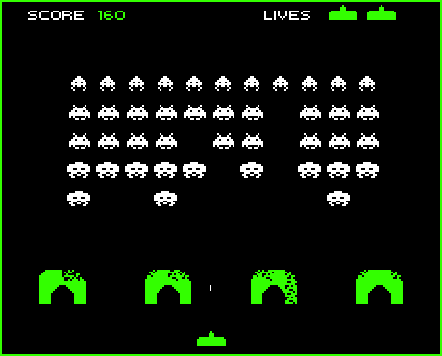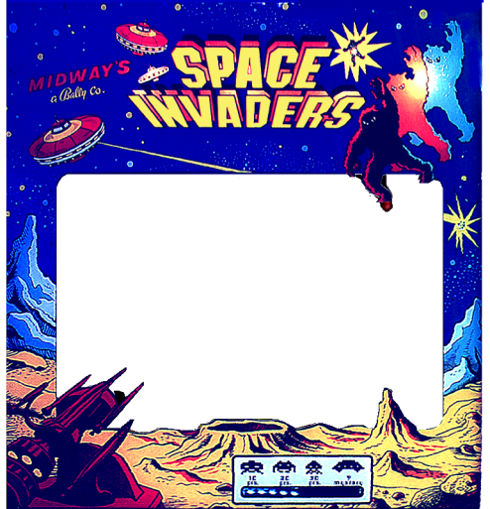

*Figure 10.1. Space Invaders*

[*http://www.classicgaming.cc/classics/spaceinvaders/index.php*](http://www.classicgaming.cc/classics/spaceinvaders/index.php)

## System Requirements for Connect Four

You will design, implement and debug a Connect Four game. Buttons and slide pots are inputs, and the LCD and sound (Lab 7) are the outputs. The slide pot is a simple yet effective means to select which column to enter your chip. There are two possible modes for the game. In the required mode, a human plays against artificial intelligence running on the microcontroller. In addition to the above requirements, Connect Four must also satisfy

* The colored pieces must move on the LCD.
* You must implement at least a 6-row by 7-column board, but are allowed to create more rows or columns.
* Aside from size of the board, you must implement the official Connect Four rules.
* You must check for wins horizontal, vertical, and diagonals. You should also check for a draw.
* You must not allow illegal moves.
* The game must have a man versus machine mode.

For more fun, you have the option of creating a two computer mode, where the AI in one microcontroller plays against a second AI running on a second microcontroller. A similar fun option is having two microcontrollers that allow one human looking at one display to play against another human looking at a second display. The boards are connected via the UART1 ports, like Lab 9, but with full duplex communication. When running in two computer mode, you need to specify baud rate, communication protocol, and determine which side goes first. Both computers should recognize that a winner has occurred. If you implement a two-computer option, it must be done in addition to the required man versus machine mode mode.

## All students must create a proposal for their project

The first step is to make a proposal. Spring 2021 proposals should be entered at

<https://docs.google.com/document/d/1B1_PBIVwFjSoUoKt9laAcv8IgeX3e4sJ1s3r_JF9EkQ/edit?usp=sharing>

Other groups are allowed to solve similar or identical games as those proposed by other students. Good projects require students to integrate fundamental EE319K educational objectives such as I/O interfacing, data structures, interrupts, sound, and the effective implementation of real-time activities. The project **need not be** a game, but the project must satisfy the System Requirements for all games listed above. Any TA will approve the proposal by adding a comment to your proposal..

These connections are recommended (so TAs can run your code on their hardware) but not required.

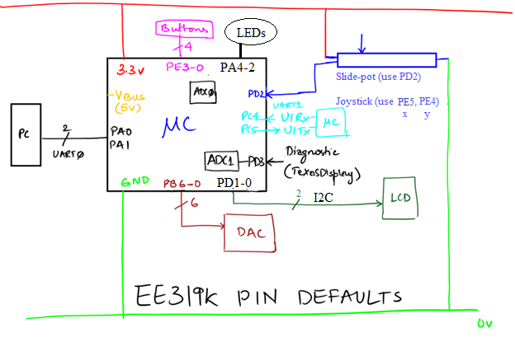

# Procedure

## Part a - Design Modules

In a system such as this each module must be individually tested. Your system will have four or more modules. Each module has a separate header and code file. Possible examples for modules include slide pot input, button input, LCD, and sound output. For each module design the I/O driver (header and code files) and a separate main program to test that particular module. Develop and test sound outputs as needed for your game. There should be at least one external switch and at least one slide pot.

## Part b - Make the game globally aware

One of the ABET criteria is to develop “**an ability to apply engineering design to produce solutions that meet specified needs with consideration of public health, safety, and welfare, as well as global, cultural, social, environmental, and economic factors**”. In EE319K/EE319H we will address this criteria by designing our project with a global awareness. In particular, each game must be playable in at least two languages. The startup screen must allow the user to select the language. Within the game each output string could be implemented as an array of strings, where the language is used to index into the array. A more elegant approach is to place all strings into a matrix structure, where one index is the string name, and the other index is the language. This second approach will simplify adding additional languages and provide for a more consistent feel for the string outputs throughout the game.

To get extended ASCII to display on your LCD, you will need to make the **char** data type be unsigned 8 bits (0 to 255). Within Keil, execute options, select the C/C++ tab and unclick the “Plain Char is Signed” button

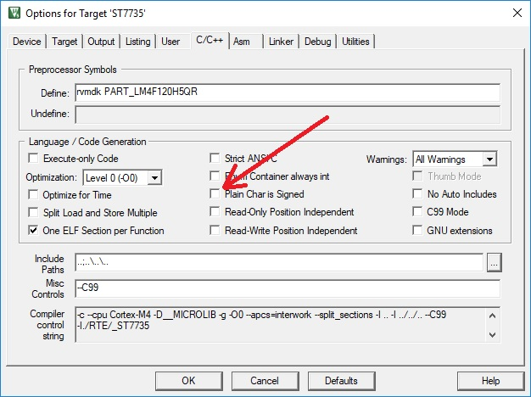

Run test code like this to see one way to output a set of phrases in multiple languages. Notice escape sequences are used to specify extended ASCII as needed for the language.

**typedef enum {English, Spanish, Portuguese, French} Language_t;**

**Language_t myLanguage=English;**

**typedef enum {HELLO, GOODBYE, LANGUAGE} phrase_t;**

**const char Hello_English[] ="Hello";**

**const char Hello_Spanish[] ="\xADHola!";**

**const char Hello_Portuguese[] = "Ol\xA0";**

**const char Hello_French[] ="All\x83";**

**const char Goodbye_English[]="Goodbye";**

**const char Goodbye_Spanish[]="Adi\xA2s";**

**const char Goodbye_Portuguese[] = "Tchau";**

**const char Goodbye_French[] = "Au revoir";**

**const char Language_English[]="English";**

**const char Language_Spanish[]="Espa\xA4ol";**

**const char Language_Portuguese[]="Portugu\x88s";**

**const char Language_French[]="Fran\x87" "ais";**

**const char *Phrases[3][4]={**

**{Hello_English,Hello_Spanish,Hello_Portuguese,Hello_French},**

**{Goodbye_English,Goodbye_Spanish,Goodbye_Portuguese,Goodbye_French},**

**{Language_English,Language_Spanish,Language_Portuguese,Language_French}**

**};**

**for(phrase_t myPhrase=HELLO; myPhrase<= GOODBYE; myPhrase++){**

**for(Language_t myL=English; myL<= French; myL++){**

**SSD1306_OutString((char *)Phrases[LANGUAGE][myL]);**

**SSD1306_OutChar(' ');**

**SSD1306_OutString((char *)Phrases[myPhrase][myL]);**

**SSD1306_OutChar(13);**

**}**

**}**

**l = 128;**

**while(1){**

**for(int i=0;i<8;i++){**

**SSD1306_SetCursor(0,i);**

**SSD1306_OutUDec(l);**

**SSD1306_OutChar(' ');**

**SSD1306_OutChar(l);**

**l++;**

**}**

**}**

**}**

Generalize this output of phrases, that uses the global language variable **myLanguage** to output a phrase in the appropriate language.

**void SSD1306_OutPhrase(phrase_t message){**

You will increase the number of phrases (and potentially decrease the number of languages)

There is a bug in the starter code for SSD1306.c and SSD1306.cpp. Comment out these 5 lines in SSD1306.c and/or SSD1306.cpp. Look around lines 255-259 or lines 237-241.

**{0x00, 0x08, 0x36, 0x41, 0x00, 0x00}, // char = 7a 123**

**{0x00, 0x00, 0x77, 0x00, 0x00, 0x00}, // char = 7b 124**

**{0x00, 0x41, 0x36, 0x08, 0x00, 0x00}, // char = 7c 125**

**{0x02, 0x01, 0x02, 0x04, 0x02, 0x00}, // char = 7d 126**

**{0x3C, 0x26, 0x23, 0x26, 0x3C, 0x00}, // char = 7e 127**

All these extended ASCII characters are off by 5 (these 5 extra mistakes)

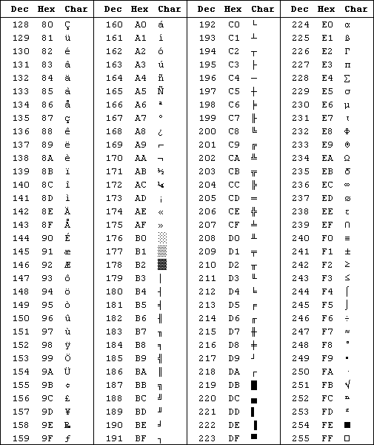

## Part c - Generate Sprites

In the game industry an entity that moves around the screen is called a *sprite*. You will find lots of sprites in the **SpaceInvadersArt** directory of the starter project. You can create additional sprites as needed using a drawing program like Paint. Most students will be able to complete Lab 10 using only the existing sprites in the starter package. You can create your own sprites by following the instructions in **BmpConvertReadme.txt**. Use **Paint** to create the image, save as 4-bit BMP images (16-color). Use **BmpConvert.exe** to create a text file. Copy the contents of the text file into your code. Use **SSD1306_DrawBMP** to place it into the RAM buffer. Use **SSD1306_OutBuffer** to send the entire RAM buffer to the OLED. For more details read section 10.1 in the book.

## Part d - Extend Random Number Generator

The starter project includes a random number generator. A C version of this function can be found in the book as Programs 2.6, 2,7, and 3.12. To learn more about this simple method for creating random numbers, do a web search for **linear congruential multiplier**. The book example will seed the number with a constant; this means you get exactly the same random numbers each time you run the program. To make your game more random, you could seed the random number sequence using the SysTick counter that exists at the time the user first pushes a button (copy the value from NVIC_ST_CURRENT_R into the private variable M). You will need to extend this random number module to provide random numbers as needed for your game. For example, if you wish to generate a random number between 1 and 5, you could define this function

**uint32_t Random5(void){**

**return ((Random32()>>24)%5)+1; // returns 1, 2, 3, 4, or 5**

**}**

It is important to shift by a large number (>>24) because the bottom bits are not very random. Seeding it with 1 will create the exact same sequence each execution. If you wish different results each time, seed it once after a button has been pressed for the first time, assuming SysTick is running

**Seed(NVIC_ST_CURRENT_R);**

## Part e - Test Subsystems

When designing a complex system, it is important to design, implement and test low-level modules first (parts a,b,c). In order to not be overwhelmed with the complexity, you must take two working subsystems and combine them. Do not combine all subsystems at the same time. Rather, we should add them one at a time. Start with a simple approach and add features as you go along.

## Part f - Optional Feedback: <http://goo.gl/forms/rBsP9NTxSy>

# **Competition Structure**

## Step 1 - Checkout and Grade (5.4% of EE319K total grade)

Checkout occurs in your usual lab checkout slot. You need to meet the base requirements and be able to answer questions about your code and hardware. Your TA will give you a sheet, which is your admission ticket to the in-class competition. Your Lab 10 checkout grade is similar to how Labs 1 to 9 were graded.

## Step 2 - YouTube Competition (0.6% for YouTube posting)

Participation in the YouTube competition is NOT optional, counting for 10% of the lab 10 grade. The posted video must be limited to a minimum of 2 minutes and a maximum of 5 minutes. All teams in the competition receive the full competition points. *Fun will be had by all.*

## Extra fun

Here are some features you may implement for extra fun~~:~~

* Edge-Triggered Interrupts with software debouncing
* Edge-Triggered Interrupts with hardware debouncing
* Multi-player game with multiple controllers
* UART used for communication with two LaunchPads
* More than 4 awesome sound effects connected to game events
* Multiple levels in game with demonstrable rise in intelligence and difficulty (however, the class demo only has about 2 minutes of playtime, so make it get to the good stuff within 2 minutes)
* Double-buffering all or part of the screen (two RAM buffers, one with image being sent to LCD and other being created by software to be output next) - Writing your pixel data to a virtual buffer and periodically updating the entire screen; this is very easy to implement with the SSD1306 at 20 frames/sec
* Layering of graphics, showing one image over top other images (clipping)
* Use of any specialized hardware (note you must write all software). An accelerometer for example.
* Joysticks can be used for the design of your own game option. The interface is simply two slide pots, which you will need to connect to two ADC channels. You will need a different sequencer from SS3 so that your software can trigger the ADC and collect conversions from two channels. See the **ADCSWTriggerTwoChan_4C123** project.
* Digital Signal Processing. You must explain what it does and how it works.
* Software implementation of volume control using a 6-bit DAC
* Design and implement an 8-bit DAC using an R-2R ladder
* Soldered on the solder-board
* Solved a distributed computing problem in a multi-player game. Each player has it’s own thread and the computer executes the threads independent of each other. The threads may be running on different LaunchPads or running on the same LaunchPad, independent of each other.